
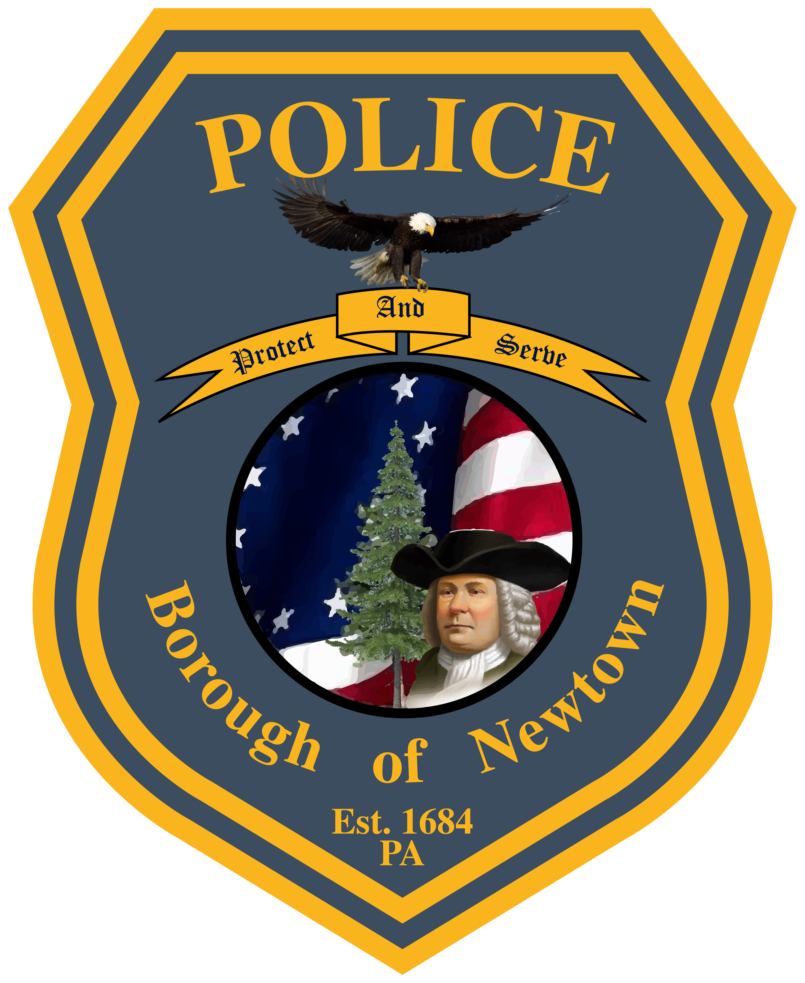

Newtown Borough
Police Department
22 Liberty Street
Newtown, Bucks County
Pennsylvania 18940

Headquarters
(215) 860-7835

Fax
(215) 860-5257
James Sabath
Chief of Police

PARKING PERMIT REGULATIONS
(1/1/2023 – 12/31/2023)

- PARKING PERMITS ARE VALID FROM 1/1/2023 THROUGH 12/31/2023

- THE COST OF THE PERMIT IS $200.00

- PERMITS ARE ONLY VALID IN THE PARKING LOT LOCATED AT 10 WEST CENTRE AVENUE (BY THE OLD NEWTOWN BEER STORE AND WINE AND SPIRIT SHOP BUILDING).

- THE PERMIT ALLOWS YOU TO EXCEED THE 3 HOUR PARKING LIMIT

- PERMITS ARE REQUIRED MONDAY THROUGH SATURDAY

- PERMITS MUST BE VISIBLY DISPLAYED ON THE INSIDE REAR-VIEW MIRROR

- IF THE PERMIT IS NOT PROPERLY DISPLAYED AND A TICKET IS ISSUED, THERE WILL BE A $5.00 ADMINISTRATIVE WITHDRAWAL FEE. REPEATED VIOLATIONS OF THIS VIOLATION AND FAILURE TO PAY THIS FEE MAY RESULT IN THE CANCELLATION OF THE PERMIT.

- PERMITS ARE NOT VALID FOR ANY ON-STREET PARKING (EXAMPLE: STATE STREET AND CENTRE AVENUE)

- EXPIRED PERMITS MUST BE RETURNED TO THE NEWTOWN BOROUGH POLICE DEPARTMENT. IF PERMITS ARE NOT TURNED IN, THEN YOU CAN NOT PURCHASE A NEW PERMIT FOR THE NEXT YEAR

- FOLLOW “NEWTOWN BOROUGH POLICE DEPARTMENT” ON FACEBOOK FOR ANY PARKING RESTICTIONS OR SNOW REMOVAL.

